Project Report

for

Tic-Tac-Toe

Version 2.0

Prepared by Kiran Qaiser, Hafsah Shahbaz

Forman Christian College (A Chartered university)

21/01/2022

**Report**

**Source:**

<https://www.geeksforgeeks.org/tic-tac-toe-game-with-gui-using-tkinter-in-python/>

**Changes:**

We have changed the grid size of the game it was a 3x3 grid and we changed it to 4x4. While doing that we also had to change the logic of the game as it was set for a 3x3 matrix. The view of the game was also changed. All the changes are described briefly under:

* **Color Change:**

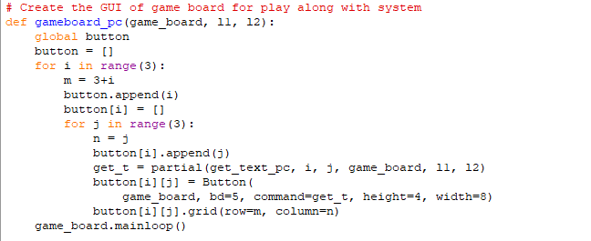

*Old Code for buttons*

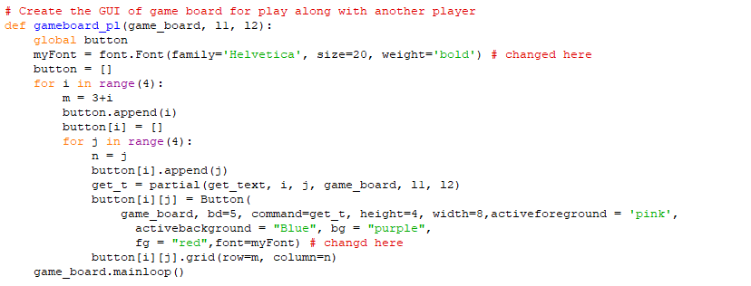

*New Code for buttons*

So we added the *activeforgrouand and activebackground* parameter to change the background and foreground of the color.

* **Size change of X&O:**



*Old Code for buttons*



*New Code for buttons*

We made *myfont* so that we could change the size of x and o and make them bolder so that it can be viewed properly.

* **3x3 to 4x4:**

We changed the matrix for 3x3 to 4x4

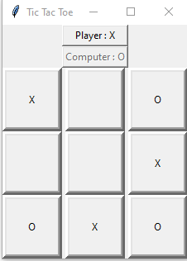 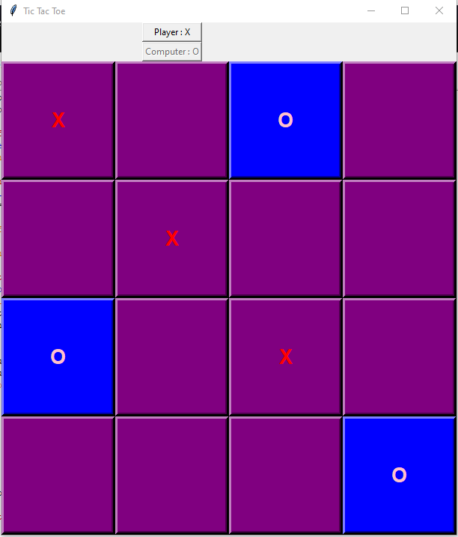

*Old Version New version*

So for changing the game size we had to change the range in boardsize from 3 to 4.

Cause of which we also needed to change the winner algorithm and the possible moves the pc could take

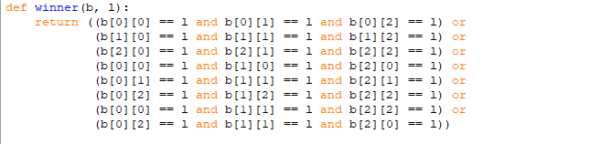

*Old Code*

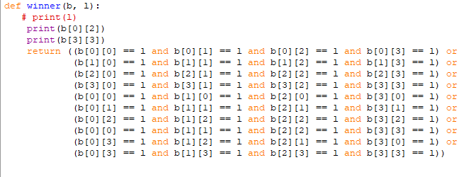

*New Code*

So we added the lines for the 4th row and column so the winner function could use it to check for the result.